National Vegetarian Week 2024
Social Media Guide for Local Authorities

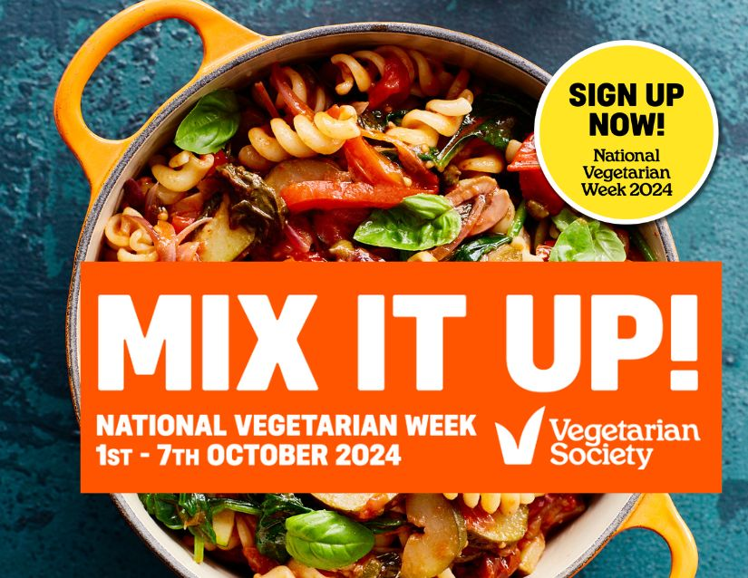
Contents

- Helpful statistics you may wish to use in your own messaging.
- Suggested social posts for National Vegetarian Week 2024.
- Showcasing your own initiatives on food and climate.
- Suggested social posts based on key themes for 2024.

1. Helpful statistics you may wish to use in your own messaging

UK statistics of current vegetarians and vegans from YouGov https://yougov.co.uk/topics/society/explore/issue/Vegetarian_Vegan?content=surveys

Of nearly 1,000 vegetarians and vegans polled by YouGov in 2022, reasons for their choice of diet varied:

- 75% said their motivation was based on their view that the way animals are farmed and killed for food is cruel
- 60% said their motivation was based on environmental reasons (in the 18-24 age group this increases to 76% for males and 68% for females)
- 26% said their motivation was based on reasons of personal health
- 94% said it was either not very difficult or not at all difficult to maintain a vegetarian or vegan diet

UK statistics of flexitarians and their thinking
https://yougov.co.uk/topics/consumer/articles-reports/2021/05/31/what-making-flexitarians-us-and-uk-shift-towards-m

- Around 1 in 5 people in the UK identify as vegan, vegetarian or flexitarian
- 13% of the UK population identify as flexitarian
- 68% of people identifying as flexitarian are actively trying to reduce their consumption of meat

YouGov survey undertaken for the Vegetarian Society - total sample size was 2085 adults. Fieldwork was undertaken between 27th - 28th April 2022. The survey was carried out online. The figures have been weighted and are representative of all GB adults (aged 18+).

- 27% of all UK adults are thinking about cutting down on the amount of meat they eat

2. Suggested social media posts encouraging people to sign up to the campaign.

(Click on this Dropbox folder link for image assets https://www.dropbox.com/scl/fo/31tn3u047k6r2dsazru9a/APMJhitj2J-m0ntuVM1tA74?rlkey=5x5h1li647k3y8mznjmu946zi&st=h32wmvkw&dl=0 )

For Facebook and Instagram | For X | Example image (full size images in Dropbox link)
Got an appetite to save the planet? MIX IT UP! Sign up to take part in National Vegetarian Week 2024 (1st -7th October) and check out the FREE DIGITAL BOOKLET packed full of veggie info, as well as delicious vegetarian and vegan recipes from a host of celebrity chefs and food writers.  #MixItUp #NationalVegetarianWeek  🔗 https://www.nationalvegetarianweek.org/ | Got an appetite to save the planet? MIX IT UP! Sign up to take part in National Vegetarian Week 2024 (1st -7th October) and check out the FREE DIGITAL BOOKLET packed full of veggie info and recipes. #MixItUp #NationalVegetarianWeek  🔗 https://www.nationalvegetarianweek.org/ | 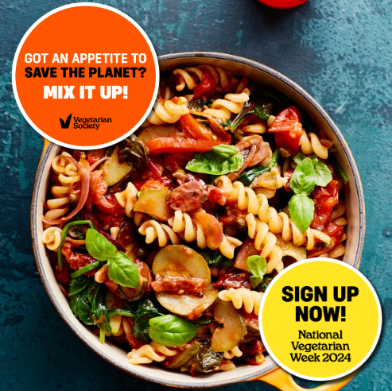
National Vegetarian Week is the perfect time to give vegetarian food a go! And, whether it’s going veggie all week or just for one meal, you’ll be making a real difference for our planet. Sign up today and check out the free digital recipe booklet packed full of delicious recipes from a host of celebrity chefs and food writers. #MixItUp 🔗 https://www.nationalvegetarianweek.org/ | Whether you are going veggie all week or just for one meal, you’ll be making a real difference for our planet. Sign up today for a free #NationalVegetarianWeek booklet packed full of delicious recipes. #MixItUp 🔗 https://www.nationalvegetarianweek.org/ | 
It’s nearly National Vegetarian Week – will you take part this year? Sign up today and check out the free digital booklet containing a range of mouth-watering plant-based recipes from a host of your favourite celebrity chefs and food writers. #MixItUp 🔗 https://www.nationalvegetarianweek.org/ | It’s nearly National Vegetarian Week – will you take part this year? Sign up today and check out the free digital booklet containing a range of mouth-watering plant-based recipes from a host of your favourite celebrity chefs. #MixItUp 🔗 https://www.nationalvegetarianweek.org/ | 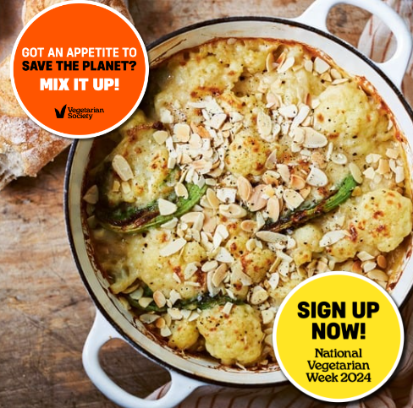
Looking for recipe inspiration? Sign up for National Vegetarian Week and check out the free digital recipe booklet packed full of gorgeous veggie and vegan recipes from a host of celebrity chefs and food writers.  🔗 https://www.nationalvegetarianweek.org/ | Looking for recipe inspiration? Sign up for National Vegetarian Week and check out the free digital recipe booklet packed full of gorgeous veggie and vegan recipes from a host of celebrity chefs and food writers.  🔗 https://www.nationalvegetarianweek.org/ | 

3. Showcasing your own initiatives on food and climate

You may wish to illustrate how your own authority is taking action on food and climate as part of your own climate emergency planning

The run up to the week and the week itself are a good time to promote your own work on net-zero, for instance:

- Are you looking to increase the provision of plant-based foods in your own catering
- Are you championing local vegetarian or vegan cafes and restaurants or those with great vegetarian and vegan offerings
- Are you seeking to increase plant-based provision within school meals
- Are you running any workshops or learning sessions for local people on food, climate justice and health

Suggested examples of how you might frame social posts for your own activity:

- It’s #NationalVegetarianWeek and to help reduce our carbon footprint we’re serving #meatfree meals in our canteen all week. Find out how you can help the planet at 🔗 https://www.nationalvegetarianweek.org/

- Head to the canteen today and try our delicious [insert vegetarian or vegan dish]. Plant-based food has a much lower carbon footprint, so by choosing more veggie meals, you’re making real carbon savings! 🔗 https://www.nationalvegetarianweek.org/

- We are having a #meatfree week at [name of school/university] to celebrate #NationalVegetarianWeek 1st-7th October. Plant-based food is better for the planet, and National Vegetarian Week is the perfect time to give vegetarian food a go! Whether it’s going veggie all week or just for one meal – you’ll still be making a real difference. #MixItUp🔗 https://www.nationalvegetarianweek.org/

- Our catering staff are having a blast this week cooking up #plantbased dishes for #NationalVegetarianWeek 1st-7th October – check out their brilliant veggie meals here 🔗 https://www.nationalvegetarianweek.org/

Remember to add in #NationalVegetarianWeek and #MixItUp to your posts as we’ll be looking for the # and resharing.

4. Suggested posts based on key campaign themes for 2024
(Click on this Dropbox folder link for image assets https://www.dropbox.com/scl/fo/31tn3u047k6r2dsazru9a/APMJhitj2J-m0ntuVM1tA74?rlkey=5x5h1li647k3y8mznjmu946zi&st=h32wmvkw&dl=0 )

For Facebook and Instagram | For X | Example image (full size images in Dropbox link)
CLIMATE
Did you know our global food system is responsible for around 1/3 of all greenhouse gas emissions? Eating less meat and more plant-based foods is one of the easiest things we can all do if we want to play our part in limiting the impact of climate change. 🌍Sign up now for #NationalVegetarianWeek and check out our booklet crammed with delicious carbon-calculated recipes. #MixItUp 🔗 https://www.nationalvegetarianweek.org/ | Our global food system is responsible for around 1/3 of all greenhouse gas emissions. Eat less meat and more plants if you want to play your part in limiting the impact of #climatechange. 🌍Sign up now for #NationalVegetarianWeek 🔗 https://www.nationalvegetarianweek.org/ | 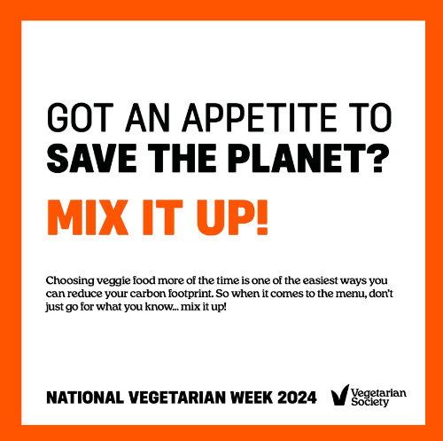
Our global food system is responsible for around 1/3 of all greenhouse gas emissions. Eat less meat and more plants if you want to play your part in limiting the impact of #climatechange. 🌍Sign up now for #NationalVegetarianWeek 🔗 https://www.nationalvegetarianweek.org/ | Our global food system is responsible for around 1/3 of all greenhouse gas emissions. Eat less meat and more plants if you want to play your part in limiting the impact of #climatechange. 🌍Sign up now for #NationalVegetarianWeek 🔗 https://www.nationalvegetarianweek.org/ | 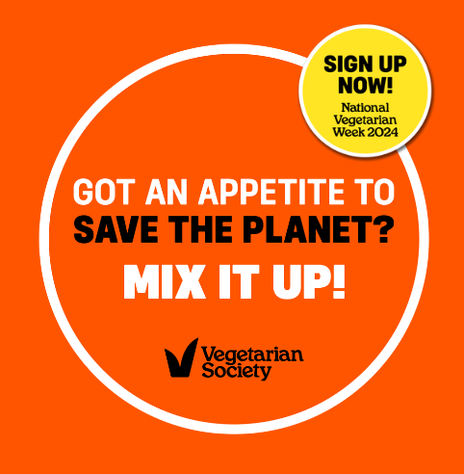
Beef tops the charts when it comes to carbon emissions! Cut down on beef & make a substantial difference to your own #carbonfootprint. MIX IT UP! with a veggie burger. Find out more by signing up to #NationalVegetarianWeek 🔗 https://www.nationalvegetarianweek.org/ | Beef tops the charts when it comes to carbon emissions! Cut down on beef & make a substantial difference to your own #carbonfootprint. MIX IT UP! with a veggie burger. Find out more by signing up to #NationalVegetarianWeek 🔗 https://www.nationalvegetarianweek.org/ | 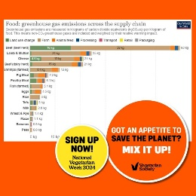
Did you know that if a family of 4 swaps a meat dish for a veggie one from the #NationalVegetarianWeek recipe booklet every day for a year, they could offset the carbon their family car produces! 🚗 🌍 MIXITUP! Find out more by signing up here 🔗www.nationalvegetarianweek.org | Did you know that if a family of 4 swaps a meat dish for a veggie one from the #NationalVegetarianWeek recipe booklet every day for a year, they could offset the carbon their family car produces! 🚗 🌍 MIX IT UP! Find out more by signing up here 🔗www.nationalvegetarianweek.org | 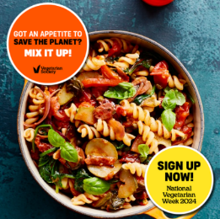
HEALTH
Research suggests that vegetarians and vegans have lower rates of heart disease, cancers and diabetes. Want to find out how you can eat better and feel better? ❤️Want to learn how to introduce more plant-based foods and replace meat in your diet? Sign up now for National Vegetarian Week 🔗https://www.nationalvegetarianweek.organd you’ll get hints, tips and great recipes to help you on your journey. #MixItUp | Research suggests that #vegetarians and #vegans have lower rates of heart disease, cancers and diabetes. Sign up for #NationalVegetarianWeek 🔗https://www.nationalvegetarianweek.org/ and you’ll get hints, tips and great recipes to help you on your journey. | 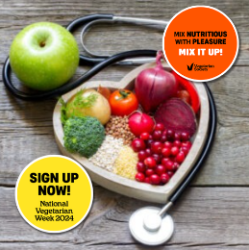
Affordability and accessibility
Eating plant-based food is not expensive. In fact, research from Oxford University suggests that eating a wholefood #vegetarian or #vegan diet can save up to a 1/3 on UK shopping bills. 👛 Find out more by signing up for #NationalVegetarianWeek #MixItUp 🔗https://www.nationalvegetarianweek.org/ | Eating veggie food is not expensive. In fact, research from Oxford University suggests eating a wholefood #vegetarian or #vegan diet can save up to a 1/3 on UK shopping bills. 👛 Find out more at #NationalVegetarianWeek #MixItUp 🔗https://www.nationalvegetarianweek.org/ | 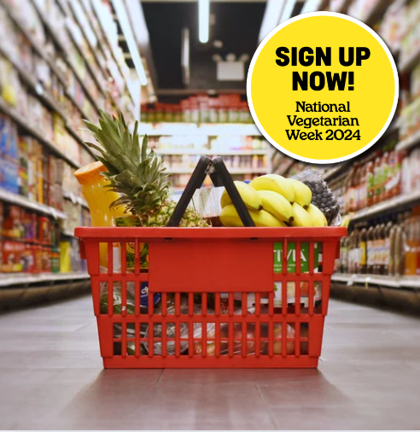
It’s time to go on a food adventure! Don’t just walk past the plant-based aisle in your local supermarket 🛒– embrace it! There is a world of wonderful veggie food waiting for you – and what’s more, they taste great and are often healthier. Find out more by signing up now for this National Vegetarian Week 1-7 October #MixItUp  🔗https://www.nationalvegetarianweek.org/ | It’s time to go on a food adventure! Don’t just walk past the plant-based aisle in your local supermarket 🛒– embrace it! A wonderful world of veggie food awaits you. Find out more by signing up for #NationalVegetarianWeek #MixItUp 🔗https://www.nationalvegetarianweek.org/ | 
All journeys start with a single step. Choosing veggie food more of the time is easy – and you can begin with just one meal. So when it comes to the menu, don’t just go for what you know…MIXITUP! Sign up now for National Vegetarian Week 1-7 October 2024 #MixItUp #NationalVegetarianWeek🔗https://www.nationalvegetarianweek.org/ | Choosing veggie food more of the time is easy – and you can begin with just one meal. When it comes to the menu, don’t just go for what you know…#MixItUp! Sign up now for #NationalVegetarianWeek 1-7 October 2024 🔗https://www.nationalvegetarianweek.org/ | 
Want to eat more plant-based foods but don’t know where to start, what to buy, what recipes to try? Let us build your confidence step by step with hints, how to guides and recipes for everyone. Sign up now for #NationalVegetarianWeek #MixItUp https://www.nationalvegetarianweek.org/ | Want to eat more plant-based foods but don’t know where to start? Let us build your confidence step by step with hints, how to guides and recipes for everyone. Sign up now for #NationalVegetarianWeek #MixItUp https://www.nationalvegetarianweek.org/

(Click on this Dropbox folder link for image assets https://www.dropbox.com/scl/fo/31tn3u047k6r2dsazru9a/APMJhitj2J-m0ntuVM1tA74?rlkey=5x5h1li647k3y8mznjmu946zi&st=h32wmvkw&dl=0 )

Other images in the Dropbox folder:
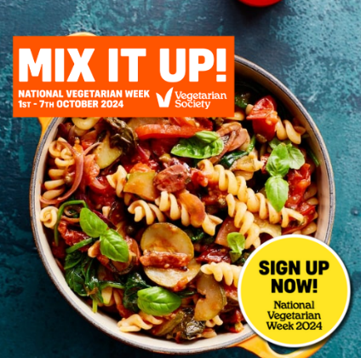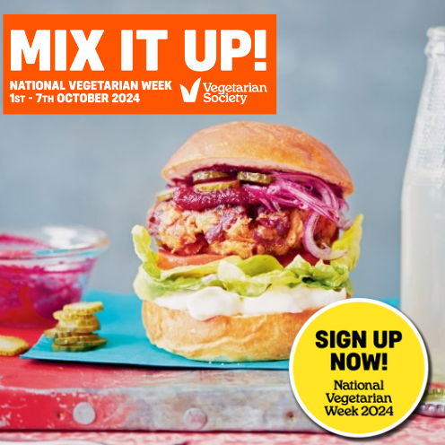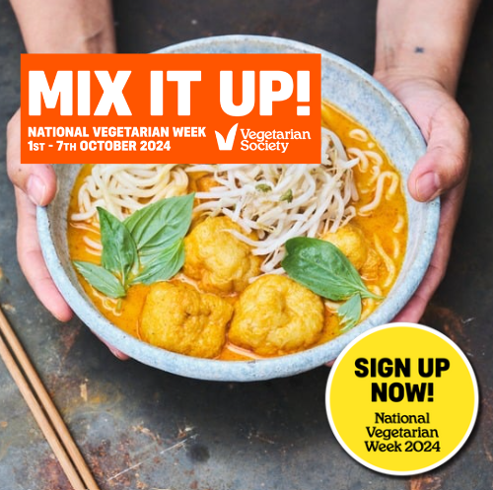

Thank you for supporting National Vegetarian Week 2024.

